**M code**

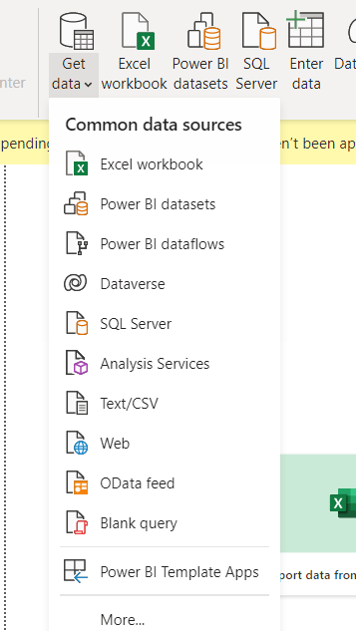

**Select Blank query to write own M code**

**To know which functions r there in power BI**

**=#shared**

**To know about the function click on value**

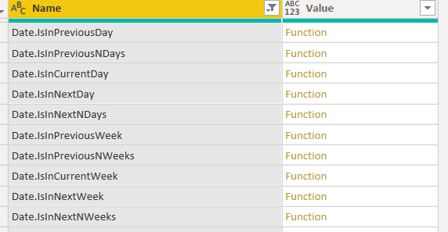

**Just few functions screen shot**

